Fairtrade Fortnight comms pack 2022
#FairtradeAtOxUni #Fairtradefortnight @OxfordEnvSust
Fairtrade Fortnight 2022 will take place from 21 February – 4 March 2022.
Oxford has been a proud Fairtrade University since June 2018, along with several of its constituent colleges. Fairtrade Fortnight is an opportunity to share the message of Fairtrade and conscious consumption in general.
We appreciate the support of the comms community in the University and colleges by sharing the following messages and resources.
Please contact vered.balan@admin.ox.ac.uk if you have any questions or remarks.

Key messages:
- Follow #FairtradeAtOxUni to learn why we care about Fairtrade and how you can join in. Fairtrade empowers farmers and workers to improve their living standards, the welfare of their communities and our shared environment.
- Fairtrade supports climate justice by working with those at the forefront of the climate crisis.
- Take part in #Fairtradefortnight, and you could win a glorious hamper of Fairtrade products.
- Fairtrade rallies a global community of millions – farmers and workers, supply chain partners, brands, retailers, shoppers, schools, governments – to pay fair prices and uphold fair production standards and practices.
- Fair standards and practices promote sustainable farming to protect biodiversity and the environment. They also deliver training for women to participate and lead secure worker rights and help tackle climate change.

How to take part?
- Join a Fairtrade Fortnight event in your college, department, team or online. See our engagement packs for a list of suggested events.
- Buy Fairtrade products at University outlets or college dining and selling points.

  - Purchasing Fairtrade products with the Yoyo app will mean you get double points.
  - The University caterer Compass and some of the colleges will offer their own raffle for those who buy Fairtrade.
  - We prepared a map of shops across Oxford where you can get Fairtrade products from food and drink to clothes and jewellery.
- If you are a student, join the Oxford Carbon Challenge and pledge to buy Fairtrade.
- Take the Fairtrade quiz (see links on our website and engagements packs.
To evaluate the impact of the Fairtrade campaign at Oxford University, we kindly ask you to dedicate a few minutes in completing this survey. Please hsare the survey con your communication channels as well.

More information, resources and links are available on our website.
With every action you take, you increase your chance to win a Fairtrade hamper.
Each action will entitle you and your college to a Fairtrade point. At the end of the fortnight, we will draw a winner who will receive a hamper of Fairtrade products. The college with the greatest participation rate will receive another hamper of Fairtrade treats for the common room.

Communication resources

Suggested text for newsletter:
[Join our Fairtrade activity…]
Oxford University and [some of its constituent colleges/ our college] have been a proud Fairtrade University since June 2018. Fairtrade Fortnight is an opportunity to share the message of Fairtrade and conscious consumption and to remind ourselves how we can support environmental and social sustainability.
Fairtrade is about justice - social, economic and environmental. The growing challenges of climate change affect farmers and workers in the communities that produce our day-to-day products. By being paid a fair rate, farmers, producers, and communities are better equipped to meet their everyday needs and deal with the challenges posed by climate change.

What can we do?
- Buy Fairtrade products [at University outlets and college dining and selling points] and on high street shopping. Encourage your friends to do the same.
o Don’t know where? here is a map showing some of the local shops and sites (link)
- If you are a student and you haven’t yet, join the Oxford Carbon Challenge and pledge to buy Fairtrade.
- Take the Fairtrade quiz (link will follow).
- Share your Fairtrade actions and commitment on social media and tag us: #FairtradeAtOxUni@OxfordEnvSust

Suggested images for screens:

All the graphic files are available to download at this link.
For a link to the files on Canva (which you can amend), email vered.balan@admin.ox.ac.uk
Alt-text: A drawing of earth with trees and hands. Text: Fairtrade Fortnight, Choose the world you want, 21 February – 6 March 2022

Alt-text: Choose the world you want. A Festival of Fairtrade and you. 21 February – 6 March 2022. More details on our website
sustainability@admin.ox.ac.uk and social media #FairtradeAtOxUni
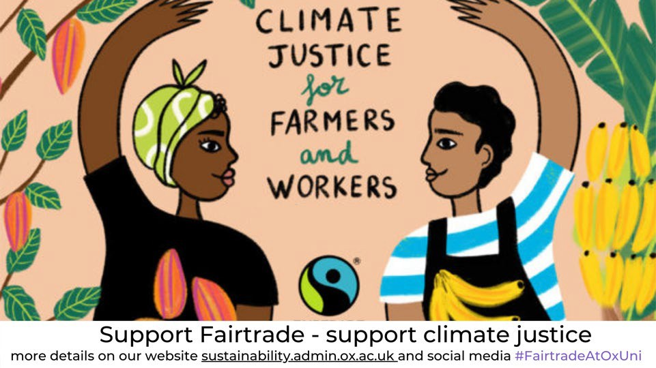 Alt-text: Climate justice for farmers and workers. Support Fairtrade – support climate justice. More details on our website sustainability@admin.ox.ac.uk and social media #FairtradeAtOxUni

Suggested Social Media Posts
It is Fairtrade Fortnight. Fairtrade empowers farmers and workers to improve their living standards, the welfare of their community and our shared environment. Oxford is a Fairtrade University, along

with some of the colleges. Check our website and look out for #FairtradeAtOxUni on social media to learn why we care and how you can get involved.
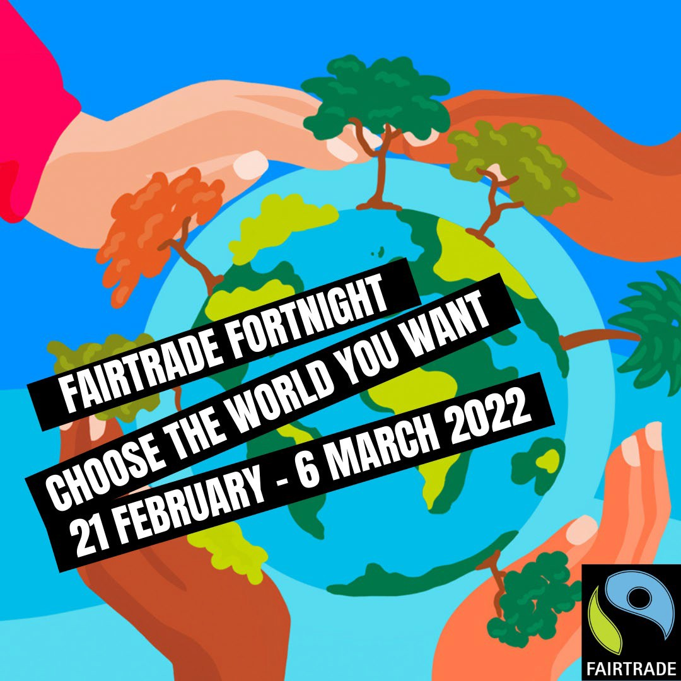 Alt-text: A drawing of earth with trees and hands. Text: Fairtrade Fortnight, Choose the world you want, 21 February – 6 March 2022

Join #Fairtradefortnight online events from around the world. From cooking and storytelling to meet the farmers and producers. There is something for everyone, and it is all accessible online https://www.fairtrade.org.uk/choose-the-world-you-want/.
Share your impressions with your friends and with #FairtradeAtOxUni
Alt-text: Choose the world you want. A Festival of Fairtrade and you. More details on our website sustainability.admin.ox.ac.uk and social media #FairtradeAtOxUni. 21 February – 6 March

The climate crisis is an immediate threat. Those in climate-vulnerable countries are already seeing its impacts, from droughts and crop disease to floods, heatwaves and shrinking harvests. With more

money through Fairtrade, they feel more equipped to meet their everyday needs and deal with the challenges posed by climate change. Join this event to learn more https://bit.ly/3uC6niV

Tweeter version: The climate crisis is an immediate threat. Those in climate-vulnerable countries are already seeing its impacts: droughts, crop disease, floods, heatwaves and shrinking harvests. The Fairtrade scheme helps them to meet their everyday needs and deal with these challenges. Join this event to learn more https://bit.ly/3uC6niV
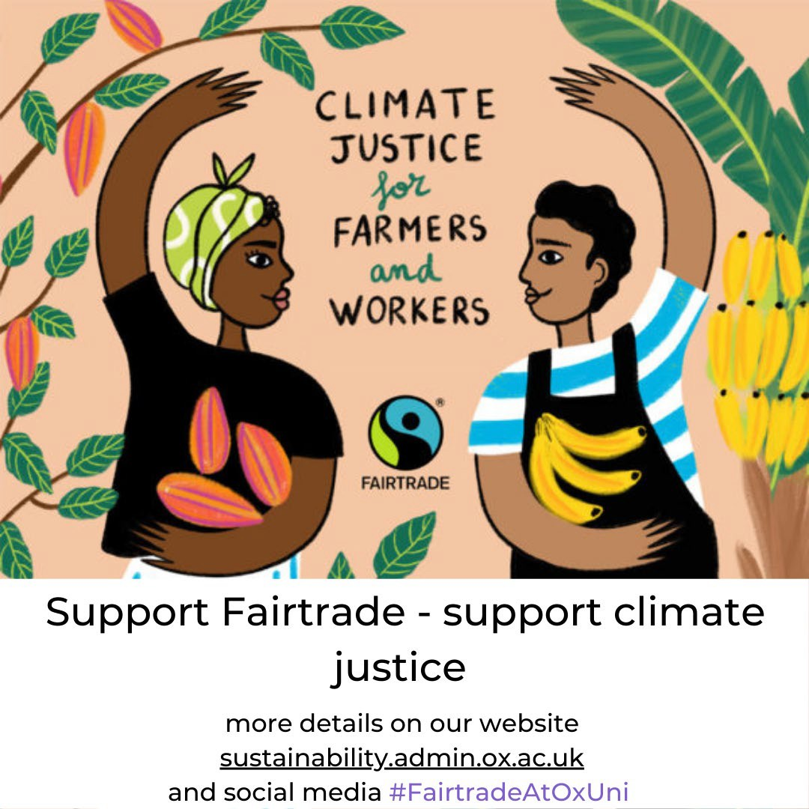Alt-text: Climate justice for farmers and workers. Support Fairtrade – support climate justice. More details on our website sustainability@admin.ox.ac.uk and social media #FairtradeAtOxUni

Love chocolate? So do we. Make sure you buy Fairtrade chocolate!
Fair standards and practices for cocoa farmers promote sustainable farming and protect biodiversity and the environment. Try this chocolate quiz; how well did you do? http://bit.ly/3qccjtZ

Alt-text: Image of cocoa farmers. Choose the
world you want
Where can you buy Fairtrade in Oxford?
@oxfairtrade @indieOxford @FT_StMichaels @Headington_FT @OxfamStGiles
Buying Fairtrade from independent shops in and around Oxford supports local businesses and Fairtrade producers. See our map [https://bit.ly/3HHNSxi], where you can find many Fairtrade items from clothing and jewellery to food and drinks.
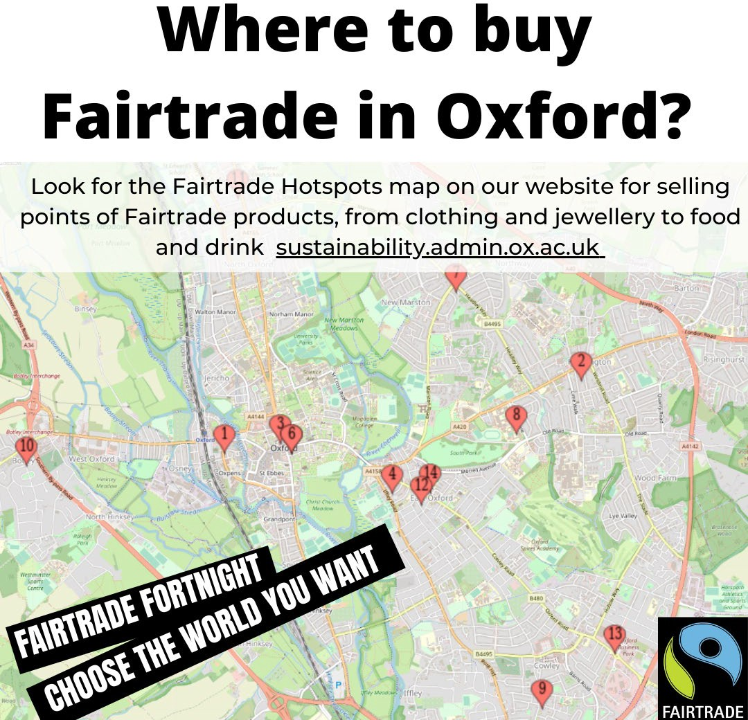
@fairtradeUK #choosefairtrade

Alt-text: Where to but Fairtrade in Oxford. Look for Fairtrade hotspots map on our website for selling points of Fairtrade products, from clothing and jewellery to food and drinks sustainability.admin.ox.ac.uk

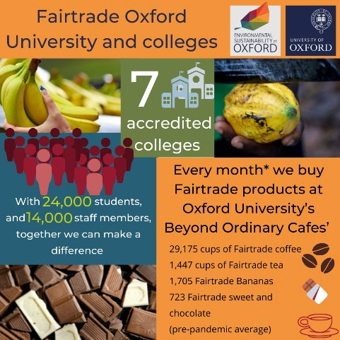
Small daily actions make a big difference to others and the environment – choose the world you want – fair, sustainable and just.

Alt-text: Fairtrade Oxford University and colleges. Seven accredited colleges. With 24,000 students and 14,000 staff members, together, we can make a difference. Every month* we buy Fairtrade products at Oxford University’s Beyond Ordinary Cafes’: 29,175 cups of Fairtrade coffee, 1,447 cups of Fairtrade tea, 1,705 Fairtrade Bananas, 723 Fairtrade sweet and chocolate (pre-pandemic average)

What do you think about Fairtrade at Oxford University? Answer our survey and have a change to win a hamper with Fairtrade goods. https://sustainability.web.ox.ac.uk/event/fairtrade-fortnight- 2022
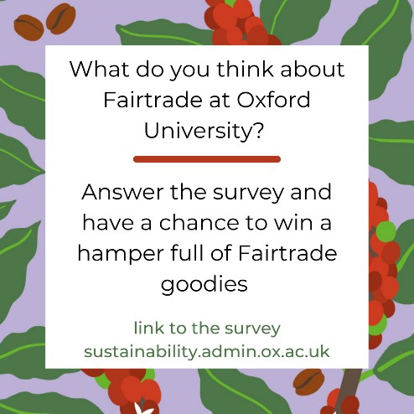

Instagram story:
Why Fairtrade? Fairtrade is about better prices, decent working conditions, local sustainability, and fair terms of trade for farmers and workers in the developing world. That’s a lot of good you can do by simply choosing Fairtrade products in your local shop.

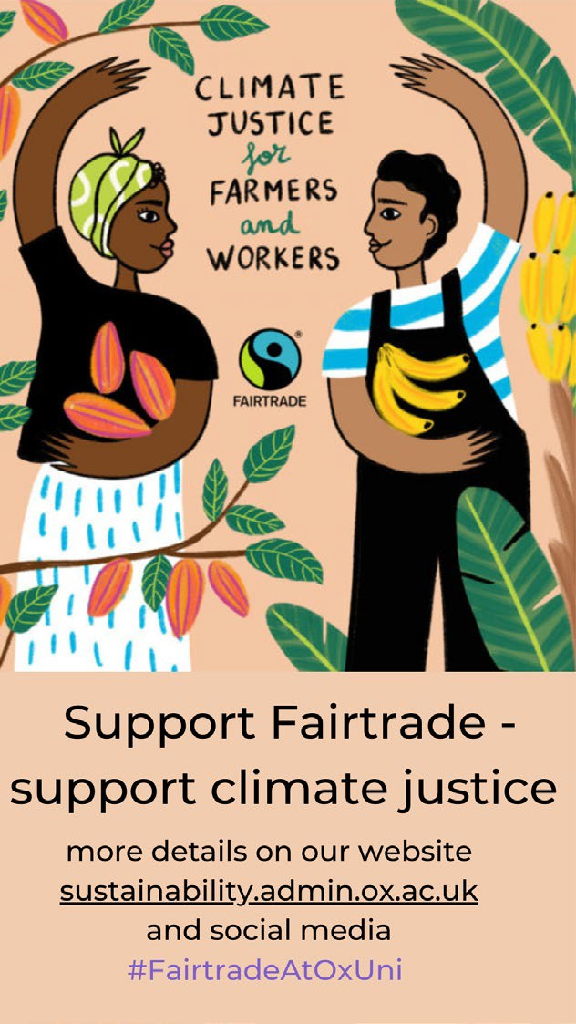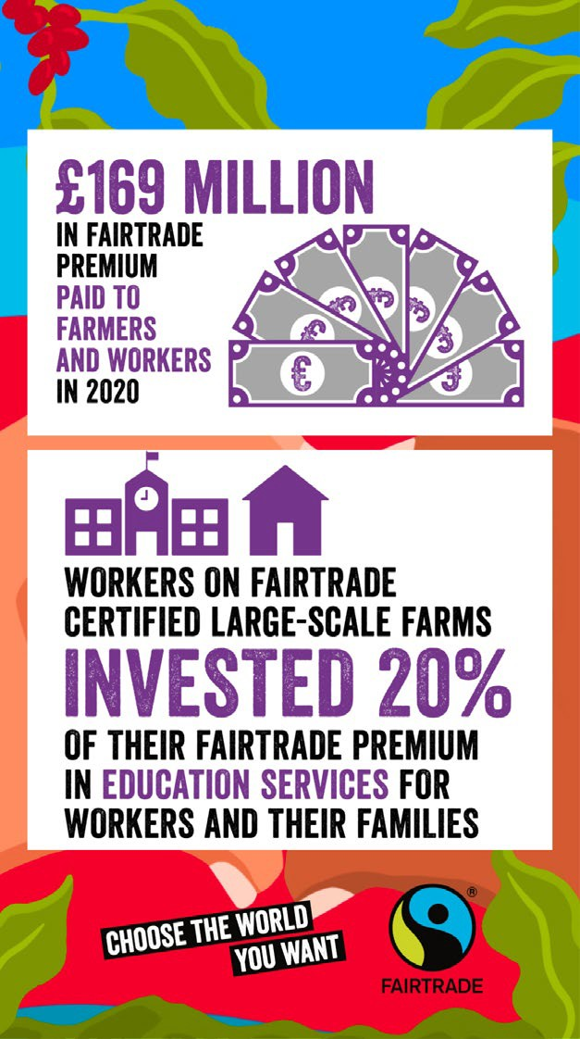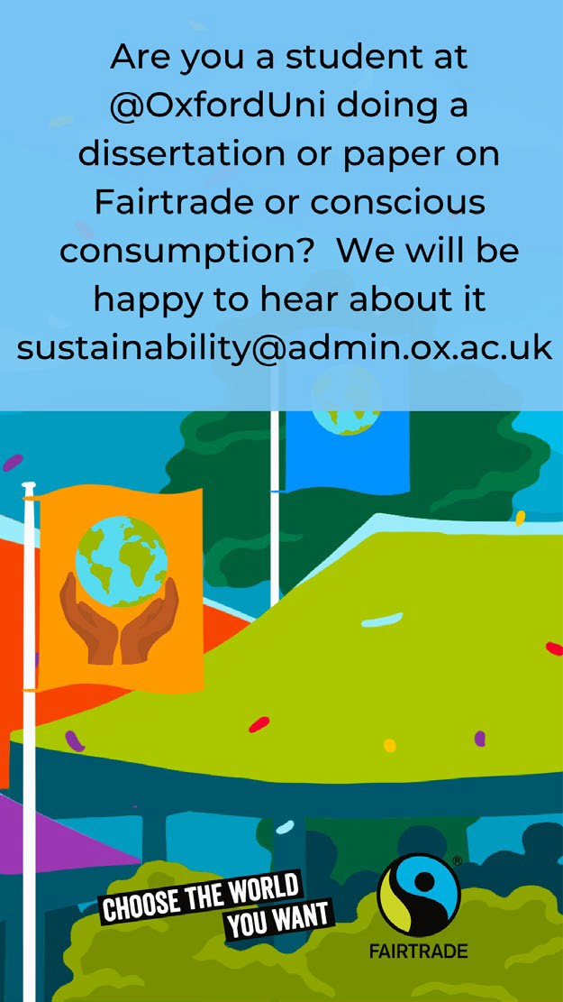

Alt-text:

Climate justice for farmers and workers. Support Fairtrade – support climate justice. More details on our website sustainability@admin.ox.ac.uk and social media #FairtradeAtOxUni | £169 Million on Fairtrade premium paid to farmers and workers in 2020. Workers on Fairtrade large-scale farms invest 20% of their Fairtrade premium in education services for workers and their families. Choose the  world you want | Are you a student at @OxfordUni doing a dissertation or paper on Fairtrade or conscious consumption? We will be happy to hear about it sustainability@admin.ox.ac.uk. Choose the world you want

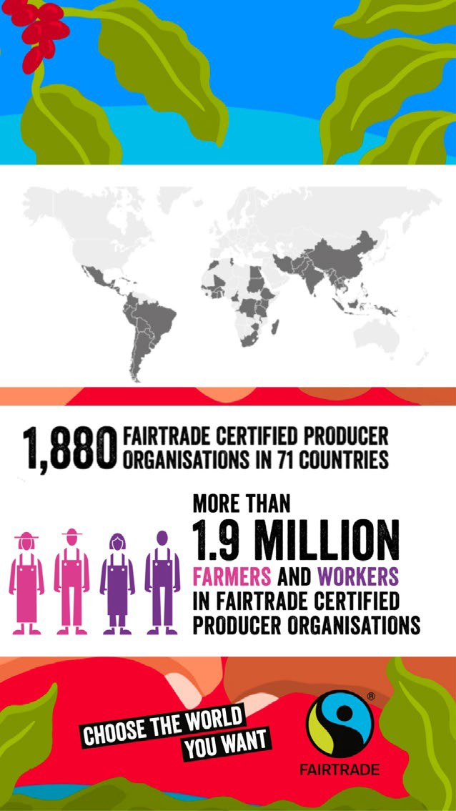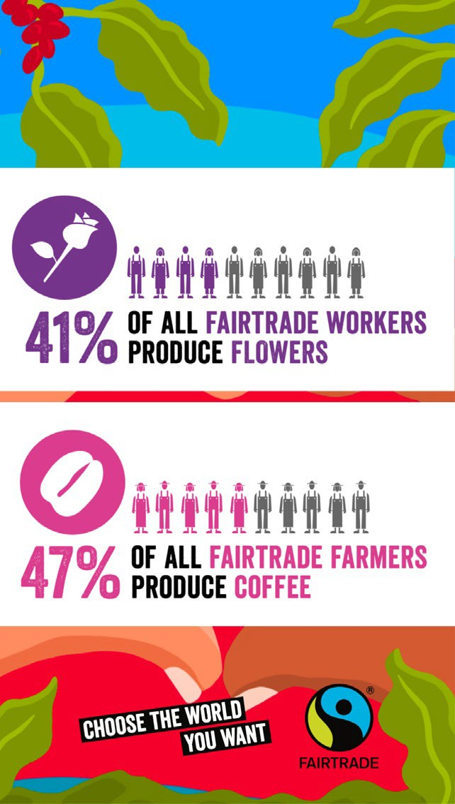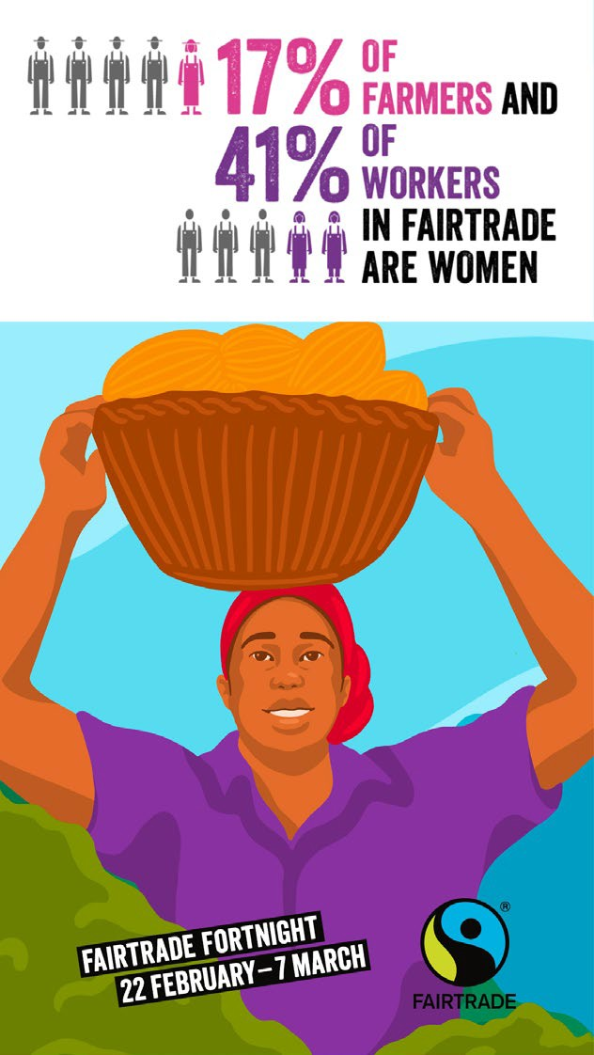Alt-text:

1,880 Fairtrade certified producers organisations in 71 countries.  More than 1.9 million farmers and workers in fairtrade certified organisations.  Choose the world you want | 41% of all Fairtrade workers produce flowers  47% of all Fairtrade farmers produce coffee. Choose the world you want | 17% of all farmers and 41% of workers in Fairtrade are women.
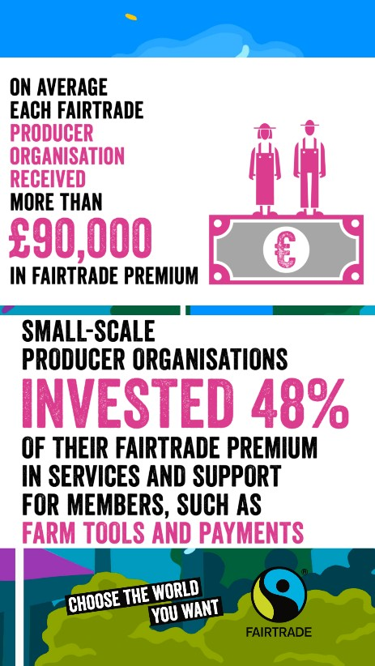 Alt-text: On average each fairtrade producers organisation receives more than £90,000 in Fairtrade premium.

Small scale producer organisations invest 48% of their premium in services and support such as farms tools and payments. Choose the world you want.

